***Tutorial 1 –Programming Environment and Package Installation***

**Install R**

* Download the R installer from <https://cran.r-project.org/>

**Figure 1. Screenshot of** <https://cran.r-project.org/>

* Run the installer. Default settings are fine. If you do not have admin rights on your laptop, then **ask you local IT support**. In that case, it is important that you also ask them to give you full permissions to the R directories. Without this, you will not be able to install additional packages later.

# Install RStudio

* Download RStudio: https://rstudio.com/products/rstudio/download/#download

**Figure 2. Download RStudio on https://rstudio.com/products/rstudio/download/#download**

* Once the installation of R has completed successfully (and not before), run the RStudio installer.
* If you do not have administrative rights on your laptop, step 2 may fail. Ask your IT Support or download a pre-­‐built zip archive of RStudio which doesn’t need installing. The link for this is towards the bottom of the download page, highlighted in Image 2.
  + Download the appropriate archive for your system (Windows/Linux only – the Mac version can be installed into your personal “Applications” folder without admin rights).
  + Double clicking on the zip archive should automatically unpack it on most Windows machines.

# Check that R and RStudio are working

* Open RStudio. It should open a window that looks similar to Fig. 3 below.
* In the left hand window, by the ‘>’sign, type ‘4+5’(without the quotes) and hit enter. An output line reading ‘[1] 9’ should appear. This means that R and RStudio are working.
* If this is not successful, contact us or your local IT support for further advice

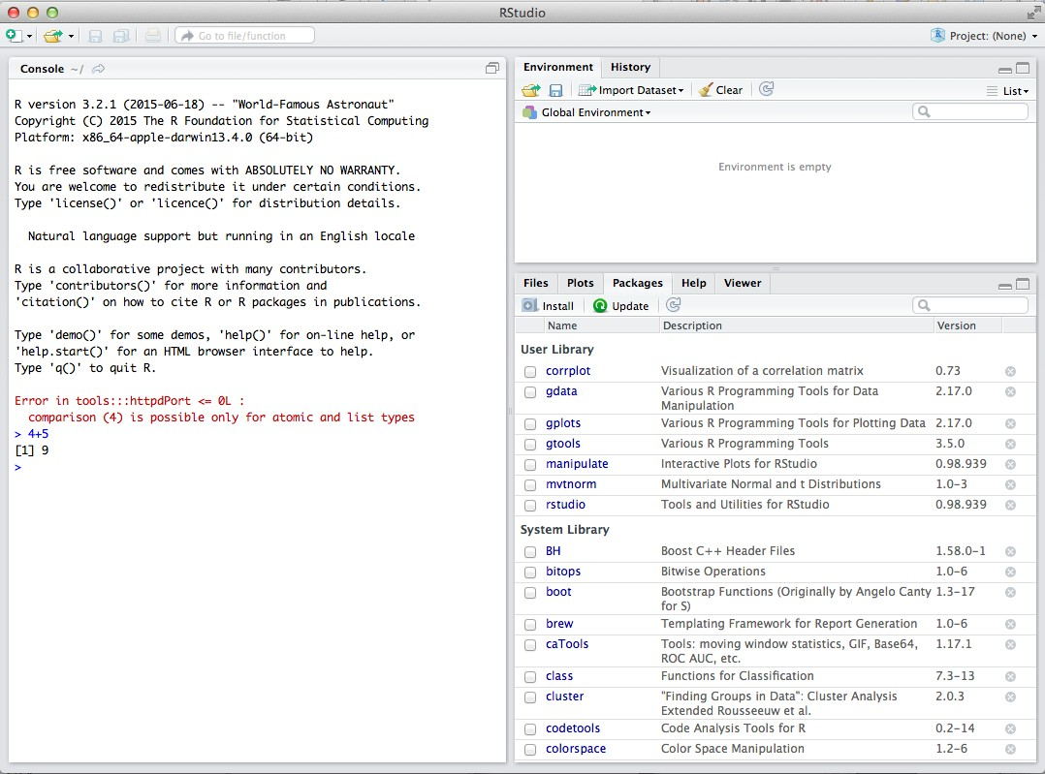

**Figure 3. Running R with RStudio**